WellPlanTM Report

Нефть Шельф
Well Name: PH-11
Wellbore:
Design:
Case: PH-11

Date: April 7, 2026 at 6:31 PM

Created By: edm

General Information
  - General Case Information
Company | Нефть Шельф
Project | Нагнетательная скважина | Site | МЛСП
Well | PH-11 | Wellbore
Design |  | Case | PH-11
Hole MD | 2945,00 m | Hole TVD | 2162,80 m
Air Gap | 35,00 m | Water Depth | 50,00 m
Reference Point | Datum #1 @ m | Well Type | Platform
  - Active Fluid

Fluid Data
Fluid | Mud #1 | Type | Mud
Mud Base Type | Brine | Base Fluid | Brine
Rheology Model | Newtonian | Foamed

Compressibility Data
Oil (Vol)/Water (Vol) | 80,00 %/20,00 % | Reference Temperature | 21,111
Salt Content (wt) | 10,00 | Average Solid Gravity | 2,000

Rheology Data
Temperature  (°C) | Pressure  (kPa) | Base Density  (kg/m³) | Ref Fluid Properties | PV (Mulnf)  (mPa*s) | Fann Data
 |  |  |  |  | Speed  (rpm) | Dial  (°)
21,111 | 101,35 | 812 | Yes | 24
  - Hole Section
Section  Type | Section Depth  (m) | Section Length  (m) | Shoe Depth  (m) | ID  (mm) | Drift  (mm) | Eff. Hole Diameter  (mm) | Coefficient  of  Friction | Linear Capacity  (L/m) | Volume  Excess  (%)
Casing | 2945 | 2945 | 2945 | 220,5 | 219,08 | 311,15 | 0,23 | 38,19
  - String Details
Type | Length  (m) | Depth  (m) | Body |  | Stabilizer / Tool Joint |  |  |  | Weight | Material | Grade | Class
 |  |  | OD  (mm) | ID  (mm) | Avg Joint Length  (m) | Length  (m) | OD  (mm) | ID  (mm)
Tubing | 2943 | 2943 | 139,7 | 124,26 |  |  |  |  | 25,3 | CS_API 5CT | L-80
Packer | 2 | 2945 | 214 | 100,5 | 2 |  |  |  | 50 | CS_API 5CT | 4145H MOD

Grade in Use
Grade | Minimum Yield Stress (kPa)
4145H MOD | 758 423
L-80 | 551 581
  - Wellpath - Calculation Method: Minimum Curvature
MD  (m) | INC  (°) | AZ  (°) | TVD  (m) | DLS  (°/30m) | AbsTort  (°/30m) | RelTort  (°/30m) | VSect  (m) | NS  (m) | EW  (m) | Build  (°/30m) | Walk  (°/30m)
0,00 | 0,00 | 0,00 | 0,00 | 0,000 | 0,000 | 0,000 | 0,00 | 0,00 | 0,00 | 0,000 | 0,000
10,00 | 0,10 | 336,77 | 10,00 | 0,300 | 0,300 | 0,000 | 0,01 | 0,01 | 0,00 | 0,300 | 0,000
20,00 | 0,06 | 277,68 | 20,00 | 0,259 | 0,279 | 0,000 | 0,02 | 0,02 | -0,01 | -0,120 | -177,270
30,00 | 0,04 | 278,91 | 30,00 | 0,060 | 0,206 | 0,000 | 0,02 | 0,02 | -0,02 | -0,060 | 3,690
40,00 | 0,02 | 224,62 | 40,00 | 0,098 | 0,179 | 0,000 | 0,02 | 0,02 | -0,03 | -0,060 | -162,870
50,00 | 0,05 | 135,02 | 50,00 | 0,161 | 0,176 | 0,000 | 0,01 | 0,01 | -0,02 | 0,090 | -268,800
60,00 | 0,11 | 100,33 | 60,00 | 0,224 | 0,184 | 0,000 | 0,01 | 0,01 | -0,01 | 0,180 | -104,070
70,00 | 0,18 | 105,25 | 70,00 | 0,213 | 0,188 | 0,000 | 0,00 | 0,00 | 0,01 | 0,210 | 14,760
80,00 | 0,34 | 98,95 | 80,00 | 0,487 | 0,225 | 0,000 | -0,01 | -0,01 | 0,06 | 0,480 | -18,900
90,00 | 0,75 | 93,97 | 90,00 | 1,237 | 0,338 | 0,000 | -0,02 | -0,02 | 0,15 | 1,230 | -14,940
100,00 | 1,10 | 84,38 | 100,00 | 1,145 | 0,418 | 0,000 | -0,01 | -0,01 | 0,31 | 1,050 | -28,770
110,00 | 1,69 | 75,67 | 110,00 | 1,876 | 0,551 | 0,000 | 0,04 | 0,04 | 0,55 | 1,770 | -26,130
120,00 | 2,11 | 96,78 | 119,99 | 2,428 | 0,707 | 0,000 | 0,05 | 0,05 | 0,88 | 1,260 | 63,330
130,00 | 2,38 | 110,82 | 129,98 | 1,832 | 0,794 | 0,000 | -0,05 | -0,05 | 1,25 | 0,810 | 42,120
140,00 | 2,40 | 112,66 | 139,97 | 0,238 | 0,754 | 0,000 | -0,20 | -0,20 | 1,64 | 0,060 | 5,520
150,00 | 2,91 | 118,03 | 149,96 | 1,701 | 0,817 | 0,000 | -0,40 | -0,40 | 2,06 | 1,530 | 16,110
160,00 | 3,04 | 123,72 | 159,95 | 0,967 | 0,827 | 0,000 | -0,67 | -0,67 | 2,50 | 0,390 | 17,070
170,00 | 3,65 | 130,53 | 169,93 | 2,181 | 0,906 | 0,000 | -1,02 | -1,02 | 2,97 | 1,830 | 20,430
180,00 | 3,67 | 139,55 | 179,91 | 1,727 | 0,952 | 0,000 | -1,47 | -1,47 | 3,42 | 0,060 | 27,060
190,00 | 3,58 | 133,85 | 189,89 | 1,114 | 0,960 | 0,000 | -1,93 | -1,93 | 3,85 | -0,270 | -17,100
200,00 | 4,11 | 140,31 | 199,87 | 2,051 | 1,015 | 0,000 | -2,42 | -2,42 | 4,30 | 1,590 | 19,380
210,00 | 4,64 | 139,73 | 209,84 | 1,596 | 1,042 | 0,000 | -3,01 | -3,01 | 4,79 | 1,590 | -1,740
220,00 | 5,58 | 143,01 | 219,80 | 2,952 | 1,129 | 0,000 | -3,70 | -3,70 | 5,35 | 2,820 | 9,840
230,00 | 6,22 | 139,17 | 229,75 | 2,255 | 1,178 | 0,000 | -4,50 | -4,50 | 5,99 | 1,920 | -11,520
240,00 | 6,39 | 137,63 | 239,69 | 0,719 | 1,159 | 0,000 | -5,32 | -5,32 | 6,72 | 0,510 | -4,620
250,00 | 7,48 | 141,35 | 249,61 | 3,535 | 1,254 | 0,000 | -6,24 | -6,24 | 7,50 | 3,270 | 11,160
260,00 | 7,98 | 137,42 | 259,52 | 2,182 | 1,290 | 0,000 | -7,26 | -7,26 | 8,38 | 1,500 | -11,790
268,00 | 8,28 | 139,37 | 267,44 | 1,528 | 1,297 | 0,000 | -8,11 | -8,11 | 9,13 | 1,125 | 7,313
305,69 | 8,61 | 137,54 | 304,72 | 0,339 | 1,179 | 0,000 | -12,25 | -12,25 | 12,80 | 0,263 | -1,457
334,59 | 10,11 | 146,08 | 333,24 | 2,118 | 1,260 | 0,000 | -15,95 | -15,95 | 15,68 | 1,557 | 8,865
364,24 | 10,73 | 147,26 | 362,40 | 0,663 | 1,211 | 0,000 | -20,43 | -20,43 | 18,62 | 0,627 | 1,194
393,54 | 11,39 | 138,35 | 391,16 | 1,874 | 1,261 | 0,000 | -24,89 | -24,89 | 22,02 | 0,676 | -9,123
402,90 | 11,77 | 137,07 | 400,33 | 1,470 | 1,266 | 0,000 | -26,28 | -26,28 | 23,29 | 1,218 | -4,103
423,48 | 12,61 | 134,51 | 420,44 | 1,456 | 1,275 | 0,000 | -29,39 | -29,39 | 26,32 | 1,224 | -3,732
452,39 | 15,69 | 129,17 | 448,47 | 3,468 | 1,415 | 0,000 | -34,07 | -34,07 | 31,60 | 3,196 | -5,541
481,78 | 17,22 | 128,58 | 476,66 | 1,571 | 1,424 | 0,000 | -39,30 | -39,30 | 38,08 | 1,562 | -0,602
511,09 | 16,62 | 133,07 | 504,70 | 1,471 | 1,427 | 0,000 | -44,86 | -44,86 | 44,54 | -0,614 | 4,596
540,54 | 17,34 | 134,30 | 532,87 | 0,820 | 1,394 | 0,000 | -50,81 | -50,81 | 50,76 | 0,733 | 1,253
554,20 | 17,58 | 134,72 | 545,90 | 0,595 | 1,374 | 0,000 | -53,68 | -53,68 | 53,68 | 0,527 | 0,922
559,00 | 17,66 | 134,86 | 550,47 | 0,566 | 1,367 | 0,000 | -54,70 | -54,70 | 54,71 | 0,500 | 0,875
566,78 | 17,80 | 135,09 | 557,88 | 0,604 | 1,357 | 0,000 | -56,38 | -56,38 | 56,39 | 0,540 | 0,887
595,96 | 19,13 | 135,38 | 585,56 | 1,371 | 1,358 | 0,000 | -62,94 | -62,94 | 62,89 | 1,367 | 0,298
625,52 | 20,22 | 135,33 | 613,39 | 1,106 | 1,346 | 0,000 | -70,02 | -70,02 | 69,89 | 1,106 | -0,051
654,88 | 21,27 | 136,05 | 640,85 | 1,104 | 1,335 | 0,000 | -77,46 | -77,46 | 77,15 | 1,073 | 0,736
684,48 | 22,00 | 135,76 | 668,37 | 0,748 | 1,310 | 0,000 | -85,30 | -85,30 | 84,74 | 0,740 | -0,294
713,80 | 23,47 | 135,45 | 695,41 | 1,509 | 1,318 | 0,000 | -93,40 | -93,40 | 92,67 | 1,504 | -0,317
742,82 | 26,10 | 134,56 | 721,75 | 2,746 | 1,374 | 0,000 | -101,99 | -101,99 | 101,28 | 2,719 | -0,920
771,96 | 28,26 | 133,76 | 747,67 | 2,255 | 1,407 | 0,000 | -111,26 | -111,26 | 110,83 | 2,224 | -0,824
801,12 | 30,23 | 134,17 | 773,11 | 2,037 | 1,430 | 0,000 | -121,15 | -121,15 | 121,08 | 2,027 | 0,422
830,30 | 32,24 | 134,50 | 798,06 | 2,074 | 1,452 | 0,000 | -131,73 | -131,73 | 131,90 | 2,066 | 0,339
839,10 | 32,53 | 134,45 | 805,49 | 0,993 | 1,448 | 0,000 | -135,03 | -135,03 | 135,26 | 0,989 | -0,170
859,92 | 33,22 | 134,32 | 822,98 | 0,999 | 1,437 | 0,000 | -142,94 | -142,94 | 143,34 | 0,994 | -0,187
888,94 | 34,53 | 135,05 | 847,07 | 1,418 | 1,436 | 0,000 | -154,31 | -154,31 | 154,84 | 1,354 | 0,755
918,47 | 36,02 | 135,38 | 871,18 | 1,526 | 1,439 | 0,000 | -166,42 | -166,42 | 166,85 | 1,514 | 0,335
947,47 | 37,47 | 135,32 | 894,42 | 1,500 | 1,441 | 0,000 | -178,76 | -178,76 | 179,04 | 1,500 | -0,062
964,70 | 38,03 | 135,27 | 908,04 | 0,977 | 1,433 | 0,000 | -186,26 | -186,26 | 186,46 | 0,975 | -0,087
977,12 | 38,43 | 135,24 | 917,80 | 0,967 | 1,427 | 0,000 | -191,71 | -191,71 | 191,87 | 0,966 | -0,072
1006,15 | 38,90 | 135,45 | 940,47 | 0,504 | 1,400 | 0,000 | -204,62 | -204,62 | 204,62 | 0,486 | 0,217
1035,77 | 40,47 | 135,57 | 963,26 | 1,592 | 1,406 | 0,000 | -218,11 | -218,11 | 217,88 | 1,590 | 0,122
1065,13 | 41,48 | 135,45 | 985,43 | 1,035 | 1,395 | 0,000 | -231,84 | -231,84 | 231,37 | 1,032 | -0,123
1094,25 | 43,07 | 134,77 | 1006,97 | 1,704 | 1,404 | 0,000 | -245,72 | -245,72 | 245,19 | 1,638 | -0,701
1123,81 | 45,06 | 134,73 | 1028,21 | 2,020 | 1,420 | 0,000 | -260,19 | -260,19 | 259,79 | 2,020 | -0,041
1123,90 | 45,07 | 134,73 | 1028,27 | 3,333 | 1,420 | 0,000 | -260,24 | -260,24 | 259,84 | 3,333 | 0,000
1153,27 | 47,03 | 135,03 | 1048,66 | 2,014 | 1,435 | 0,000 | -275,16 | -275,16 | 274,82 | 2,002 | 0,306
1181,61 | 48,80 | 134,30 | 1067,65 | 1,959 | 1,448 | 0,000 | -289,94 | -289,94 | 289,78 | 1,874 | -0,773
1210,04 | 50,49 | 133,70 | 1086,06 | 1,847 | 1,457 | 0,000 | -304,99 | -304,99 | 305,36 | 1,783 | -0,633
1238,45 | 51,25 | 132,90 | 1103,99 | 1,036 | 1,447 | 0,000 | -320,10 | -320,10 | 321,40 | 0,803 | -0,845
1266,90 | 51,61 | 132,46 | 1121,73 | 0,525 | 1,427 | 0,000 | -335,18 | -335,18 | 337,75 | 0,380 | -0,464
1270,80 | 51,81 | 132,50 | 1124,14 | 1,557 | 1,427 | 0,000 | -337,25 | -337,25 | 340,01 | 1,538 | 0,308
1295,38 | 53,07 | 132,77 | 1139,13 | 1,560 | 1,430 | 0,000 | -350,44 | -350,44 | 354,35 | 1,538 | 0,330
1323,59 | 54,34 | 133,09 | 1155,82 | 1,378 | 1,428 | 0,000 | -365,93 | -365,93 | 370,99 | 1,351 | 0,340
1352,23 | 55,73 | 132,59 | 1172,24 | 1,518 | 1,430 | 0,000 | -381,89 | -381,89 | 388,20 | 1,456 | -0,524
1380,79 | 56,55 | 132,18 | 1188,15 | 0,933 | 1,420 | 0,000 | -397,87 | -397,87 | 405,72 | 0,861 | -0,431
1408,90 | 56,67 | 131,87 | 1203,62 | 0,304 | 1,398 | 0,000 | -413,59 | -413,59 | 423,16 | 0,128 | -0,331
1436,68 | 56,75 | 130,23 | 1218,87 | 1,483 | 1,399 | 0,000 | -428,84 | -428,84 | 440,67 | 0,086 | -1,771
1465,74 | 56,61 | 129,72 | 1234,83 | 0,463 | 1,381 | 0,000 | -444,44 | -444,44 | 459,27 | -0,145 | -0,527
1493,74 | 56,95 | 132,22 | 1250,17 | 2,270 | 1,398 | 0,000 | -459,79 | -459,79 | 476,96 | 0,364 | 2,679
1522,61 | 57,47 | 133,55 | 1265,81 | 1,281 | 1,395 | 0,000 | -476,31 | -476,31 | 494,74 | 0,540 | 1,382
1551,24 | 57,61 | 133,25 | 1281,17 | 0,303 | 1,375 | 0,000 | -492,91 | -492,91 | 512,29 | 0,147 | -0,314
1579,64 | 58,05 | 133,67 | 1296,30 | 0,598 | 1,361 | 0,000 | -509,44 | -509,44 | 529,74 | 0,465 | 0,444
1608,02 | 58,03 | 134,98 | 1311,32 | 1,175 | 1,358 | 0,000 | -526,27 | -526,27 | 546,97 | -0,021 | 1,385
1636,53 | 58,09 | 136,07 | 1326,40 | 0,975 | 1,351 | 0,000 | -543,53 | -543,53 | 563,92 | 0,063 | 1,147
1665,16 | 58,04 | 136,37 | 1341,55 | 0,272 | 1,333 | 0,000 | -561,07 | -561,07 | 580,73 | -0,052 | 0,314
1695,34 | 58,01 | 135,54 | 1357,53 | 0,701 | 1,321 | 0,000 | -579,47 | -579,47 | 598,52 | -0,030 | -0,825
1717,90 | 58,03 | 135,58 | 1369,48 | 0,052 | 1,305 | 0,000 | -593,14 | -593,14 | 611,92 | 0,027 | 0,053
1724,41 | 58,03 | 135,59 | 1372,92 | 0,039 | 1,300 | 0,000 | -597,08 | -597,08 | 615,79 | 0,000 | 0,046
1753,66 | 57,74 | 135,71 | 1388,47 | 0,315 | 1,284 | 0,000 | -614,80 | -614,80 | 633,11 | -0,297 | 0,123
1783,15 | 57,83 | 134,21 | 1404,19 | 1,294 | 1,284 | 0,000 | -632,43 | -632,43 | 650,76 | 0,092 | -1,526
1799,40 | 57,92 | 133,72 | 1412,84 | 0,784 | 1,279 | 0,000 | -641,98 | -641,98 | 660,67 | 0,166 | -0,905
1812,42 | 58,00 | 133,33 | 1419,74 | 0,784 | 1,276 | 0,000 | -649,58 | -649,58 | 668,67 | 0,184 | -0,899
1841,71 | 58,02 | 133,29 | 1435,26 | 0,040 | 1,256 | 0,000 | -666,62 | -666,62 | 686,74 | 0,020 | -0,041
1870,92 | 57,69 | 134,24 | 1450,80 | 0,893 | 1,250 | 0,000 | -683,73 | -683,73 | 704,61 | -0,339 | 0,976
1900,18 | 58,00 | 133,19 | 1466,37 | 0,965 | 1,246 | 0,000 | -700,85 | -700,85 | 722,51 | 0,318 | -1,077
1912,10 | 57,92 | 133,17 | 1472,70 | 0,206 | 1,240 | 0,000 | -707,76 | -707,76 | 729,88 | -0,201 | -0,050
1929,45 | 57,80 | 133,14 | 1481,93 | 0,212 | 1,230 | 0,000 | -717,81 | -717,81 | 740,60 | -0,207 | -0,052
1949,40 | 57,68 | 133,17 | 1492,58 | 0,184 | 1,220 | 0,000 | -729,35 | -729,35 | 752,90 | -0,180 | 0,045
1958,92 | 57,62 | 133,18 | 1497,67 | 0,191 | 1,215 | 0,000 | -734,85 | -734,85 | 758,77 | -0,189 | 0,032
1987,73 | 57,67 | 133,42 | 1513,09 | 0,217 | 1,200 | 0,000 | -751,54 | -751,54 | 776,48 | 0,052 | 0,250
2020,39 | 58,11 | 133,76 | 1530,45 | 0,483 | 1,189 | 0,000 | -770,62 | -770,62 | 796,52 | 0,404 | 0,312
2020,50 | 58,10 | 133,75 | 1530,51 | 3,578 | 1,189 | 0,000 | -770,68 | -770,68 | 796,58 | -2,727 | -2,727
2038,40 | 57,13 | 131,58 | 1540,10 | 3,475 | 1,209 | 0,000 | -780,92 | -780,92 | 807,70 | -1,626 | -3,637
2069,04 | 55,54 | 127,77 | 1557,08 | 3,473 | 1,242 | 0,000 | -797,21 | -797,21 | 827,31 | -1,557 | -3,730
2099,71 | 52,53 | 127,11 | 1575,09 | 2,990 | 1,268 | 0,000 | -812,30 | -812,30 | 847,02 | -2,944 | -0,646
2115,30 | 51,53 | 128,56 | 1584,69 | 2,922 | 1,280 | 0,000 | -819,83 | -819,83 | 856,72 | -1,924 | 2,790
2130,56 | 50,57 | 130,01 | 1594,28 | 2,911 | 1,292 | 0,000 | -827,35 | -827,35 | 865,91 | -1,887 | 2,851
2144,94 | 50,74 | 131,27 | 1603,40 | 2,064 | 1,297 | 0,000 | -834,59 | -834,59 | 874,35 | 0,355 | 2,629
2173,16 | 50,78 | 130,12 | 1621,25 | 0,948 | 1,292 | 0,000 | -848,84 | -848,84 | 890,92 | 0,043 | -1,223
2198,20 | 50,67 | 129,89 | 1637,10 | 0,251 | 1,280 | 0,000 | -861,30 | -861,30 | 905,77 | -0,132 | -0,276
2201,81 | 50,65 | 129,86 | 1639,39 | 0,255 | 1,279 | 0,000 | -863,09 | -863,09 | 907,91 | -0,166 | -0,249
2230,67 | 50,10 | 127,69 | 1657,79 | 1,829 | 1,286 | 0,000 | -877,01 | -877,01 | 925,24 | -0,572 | -2,256
2259,55 | 48,83 | 123,45 | 1676,57 | 3,597 | 1,315 | 0,000 | -889,78 | -889,78 | 943,08 | -1,319 | -4,404
2288,13 | 46,82 | 121,38 | 1695,76 | 2,654 | 1,332 | 0,000 | -901,14 | -901,14 | 960,95 | -2,110 | -2,173
2322,59 | 42,98 | 122,22 | 1720,16 | 3,383 | 1,363 | 0,000 | -913,95 | -913,95 | 981,62 | -3,343 | 0,731
2331,50 | 42,48 | 122,70 | 1726,71 | 2,009 | 1,365 | 0,000 | -917,19 | -917,19 | 986,73 | -1,684 | 1,616
2346,88 | 41,63 | 123,56 | 1738,13 | 2,003 | 1,369 | 0,000 | -922,82 | -922,82 | 995,35 | -1,658 | 1,678
2375,22 | 41,13 | 127,30 | 1759,39 | 2,670 | 1,385 | 0,000 | -933,68 | -933,68 | 1010,61 | -0,529 | 3,959
2404,22 | 41,51 | 129,13 | 1781,18 | 1,310 | 1,384 | 0,000 | -945,52 | -945,52 | 1025,66 | 0,393 | 1,893
2415,30 | 41,58 | 129,68 | 1789,47 | 1,006 | 1,382 | 0,000 | -950,19 | -950,19 | 1031,33 | 0,190 | 1,489
2432,90 | 41,69 | 130,55 | 1802,62 | 1,003 | 1,379 | 0,000 | -957,72 | -957,72 | 1040,28 | 0,188 | 1,483
2461,89 | 42,03 | 131,20 | 1824,21 | 0,570 | 1,370 | 0,000 | -970,38 | -970,38 | 1054,90 | 0,352 | 0,673
2490,42 | 42,10 | 130,89 | 1845,39 | 0,230 | 1,357 | 0,000 | -982,93 | -982,93 | 1069,32 | 0,074 | -0,326
2519,56 | 42,12 | 131,62 | 1867,01 | 0,504 | 1,347 | 0,000 | -995,82 | -995,82 | 1084,01 | 0,021 | 0,752
2548,20 | 42,05 | 131,42 | 1888,27 | 0,158 | 1,334 | 0,000 | -1008,54 | -1008,54 | 1098,38 | -0,073 | -0,210
2576,78 | 42,59 | 131,64 | 1909,40 | 0,588 | 1,325 | 0,000 | -1021,30 | -1021,30 | 1112,79 | 0,567 | 0,231
2605,43 | 42,57 | 130,28 | 1930,50 | 0,964 | 1,321 | 0,000 | -1034,01 | -1034,01 | 1127,42 | -0,021 | -1,424
2634,27 | 42,74 | 131,09 | 1951,71 | 0,598 | 1,313 | 0,000 | -1046,74 | -1046,74 | 1142,24 | 0,177 | 0,843
2645,30 | 42,64 | 130,26 | 1959,81 | 1,555 | 1,314 | 0,000 | -1051,62 | -1051,62 | 1147,91 | -0,272 | -2,257
2663,10 | 42,49 | 128,92 | 1972,92 | 1,548 | 1,316 | 0,000 | -1059,29 | -1059,29 | 1157,19 | -0,253 | -2,258
2692,08 | 42,67 | 128,25 | 1994,26 | 0,505 | 1,307 | 0,000 | -1071,52 | -1071,52 | 1172,52 | 0,186 | -0,694
2720,52 | 43,63 | 128,08 | 2015,01 | 1,020 | 1,304 | 0,000 | -1083,54 | -1083,54 | 1187,81 | 1,013 | -0,179
2750,18 | 45,68 | 129,69 | 2036,11 | 2,368 | 1,316 | 0,000 | -1096,63 | -1096,63 | 1204,03 | 2,074 | 1,628
2778,86 | 46,87 | 131,54 | 2055,93 | 1,872 | 1,321 | 0,000 | -1110,12 | -1110,12 | 1219,76 | 1,245 | 1,935
2807,95 | 47,92 | 133,19 | 2075,63 | 1,656 | 1,325 | 0,000 | -1124,55 | -1124,55 | 1235,58 | 1,083 | 1,702
2836,88 | 47,91 | 132,61 | 2095,02 | 0,446 | 1,316 | 0,000 | -1139,17 | -1139,17 | 1251,31 | -0,010 | -0,601
2862,60 | 49,90 | 133,30 | 2111,92 | 2,399 | 1,326 | 0,000 | -1152,37 | -1152,37 | 1265,49 | 2,321 | 0,805
2865,86 | 50,15 | 133,38 | 2114,02 | 2,369 | 1,327 | 0,000 | -1154,09 | -1154,09 | 1267,31 | 2,301 | 0,736
2894,34 | 51,84 | 133,28 | 2131,94 | 1,782 | 1,331 | 0,000 | -1169,28 | -1169,28 | 1283,41 | 1,780 | -0,105
2896,00 | 51,88 | 133,24 | 2132,97 | 0,920 | 1,331 | 0,000 | -1170,17 | -1170,17 | 1284,36 | 0,723 | -0,723
2923,37 | 52,62 | 132,65 | 2149,72 | 0,959 | 1,328 | 0,000 | -1184,91 | -1184,91 | 1300,20 | 0,811 | -0,647
2951,81 | 53,11 | 133,66 | 2166,89 | 0,994 | 1,324 | 0,000 | -1200,42 | -1200,42 | 1316,74 | 0,517 | 1,065
  - Pore Pressure
True Vertical Depth (TVD)  (m) | Pore Pressure  (kPa) | Equivalent Mud Weight (EMW)  (kg/m³)
85,00 | 859,00 | 1031
  - Fracture Gradient
True Vertical Depth (TVD)  (m) | Fracture Pressure  (kPa) | Equivalent Mud Weight (EMW)  (kg/m³)
85,00 | 0,00 | 0
  - Geothermal Gradient Data
Ambient Temperature | 10,000 °C | Mudline Temperature | 1,000 °C
Temperature @ Depth | 70,000 °C @ 2162,80 m | Gradient | 3,32 °C/100m

Schematics
Well: | IH-9 | Wellbore: |  | Case: | IH-9 | String Name: | Assembly
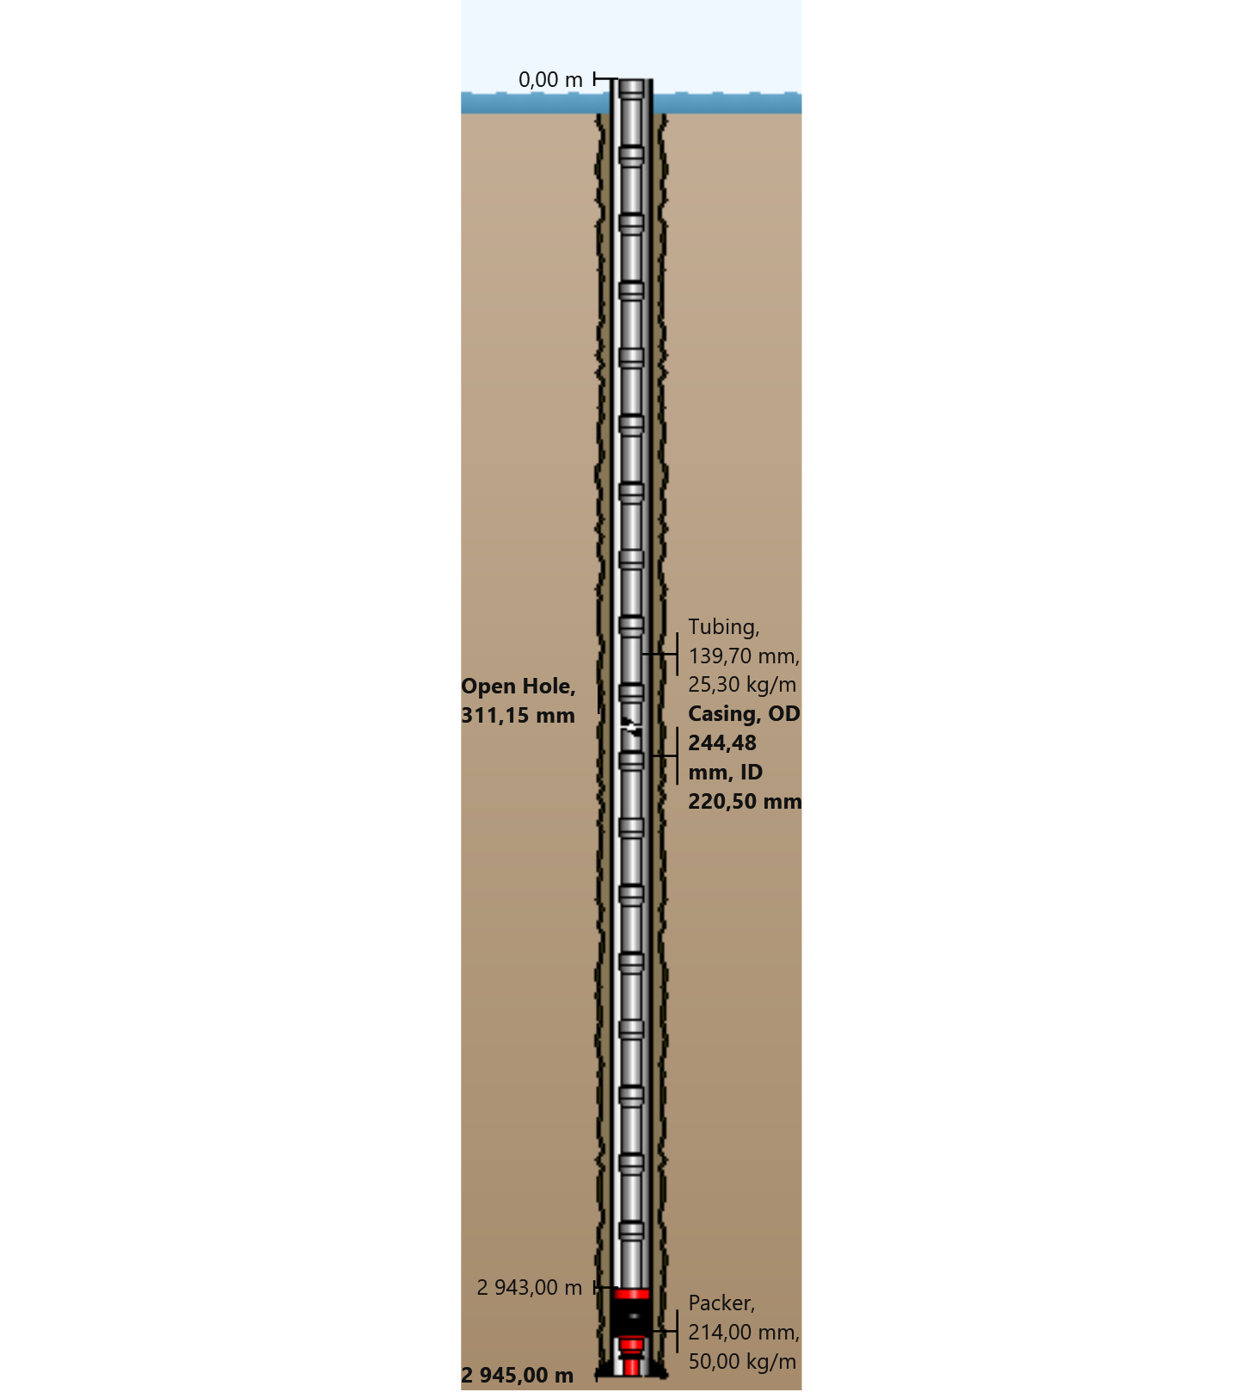

General Outputs Plots
  - Vertical Section
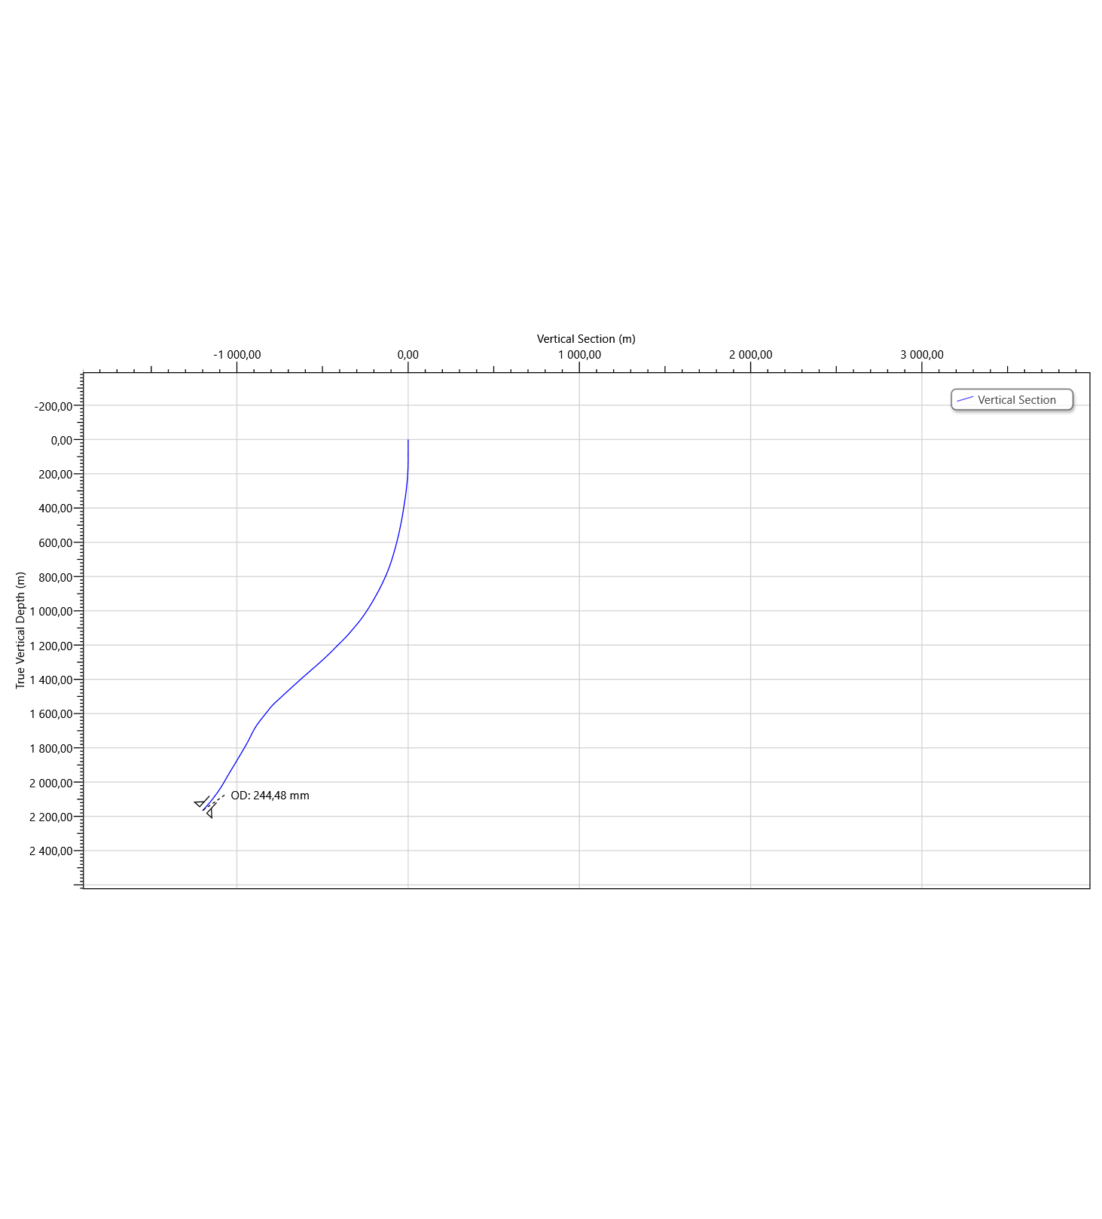
  - Plan View
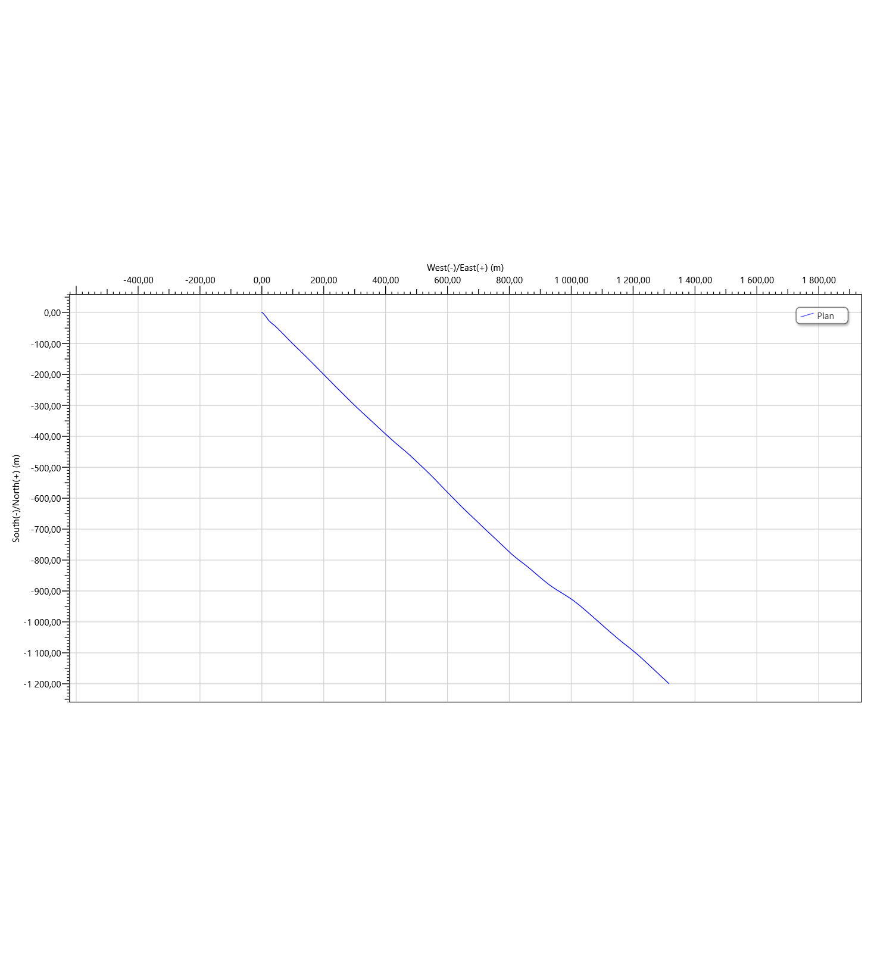

Torque & Drag Setup Data
  - Settings
Measured Depth of Bit | 2945,00 m | Bending Stress Magnification | No
Block Weight | 0,00 tonne | Stiff String Analysis | No
Enable Sheave Friction Correction | No | Viscous Torque and Drag | No
Pump Rate | 0,0000 m³/min | Contact Force Normalization Length | 9,45 m
Mechanical Efficiency (Single Sheave) | 97,00 | Lines Strung | 12
 |  | Side Force | N
Offset from Wellhead | m | Angle at Wellhead | °
  - Run Parameters
Start MD | 0,00 m | End MD | 2945,00 m
Step Size | 30,00 m
  - Normal Analysis Operational Parameters
Drilling | WOP/Overpull  (tonne) | Torque at Bit  (N-m)
Rotating On Bottom | NA | NA
Slide Drilling | NA | NA
Backreaming | NA | NA
Rotating Off Bottom
Tripping | Speed  (m/min) | RPM  (rpm)
Tripping In | 10,00 | 0
Tripping Out | 10,00 | 0
  - Friction Factors
Section Type | Coefficient of Friction
Casing | 0,23

  - String Fill Up
Use String Fill Up (Tripping In only) | No | Period | 0,00 m

Torque and Drag Results
  - Mechanical Limitations
Overpull Margin during a Tripping Out operation | 110,01 tonne | using | 100,00% of yield
Minimum Weight on Bit to Sinusoidal Buckle during a rotating on bottom operation | 17,64 tonne | at | 2821,39 m
Minimum Weight on Bit to Helical Buckle during a rotating on bottom operation | 20,61 tonne | at | 2286,30 m
Pick-Up Drag | 16,49 tonne
Slack-Off Drag | 11,33 tonne
Block Rating (Hoisting System) | tonne
Torque Rating (Rotating Equipment) | N-m
  - Load Summary
Load Condition | Stress Failure |  |  | Buckling Limits |  |  | Torque Failure | Torque at the Rotary Table  (N-m) | Total Windup with Bit Torque  (revs) | Total Windup without Bit Torque  (revs) | Measured Weight  (tonne) | Total Stretch  (m) | Axial Stress = 0 |  | Neutral Point Distance from surface  (m) | Neutral Point Distance from Bit  (m)
 | Fatigue | 90% Yield | 100% Yield | Sinusoidal | Helical | Lockup |  |  |  |  |  |  | Distance from Surface  (m) | Distance from Bit  (m)
Tripping In |  |  |  |  |  |  |  | 0,0 | 0,0 | 0,0 | 37,76 | 1,67 | 2543,18 | 401,82 | 2945,00 | 0,00
Tripping Out |  |  |  |  |  |  |  | 0,0 | 0,0 | 0,0 | 65,58 | 2,24 | 2670,84 | 274,16 | 2945,00 | 0,00

Torque and Drag Plots
  - Effective Tension
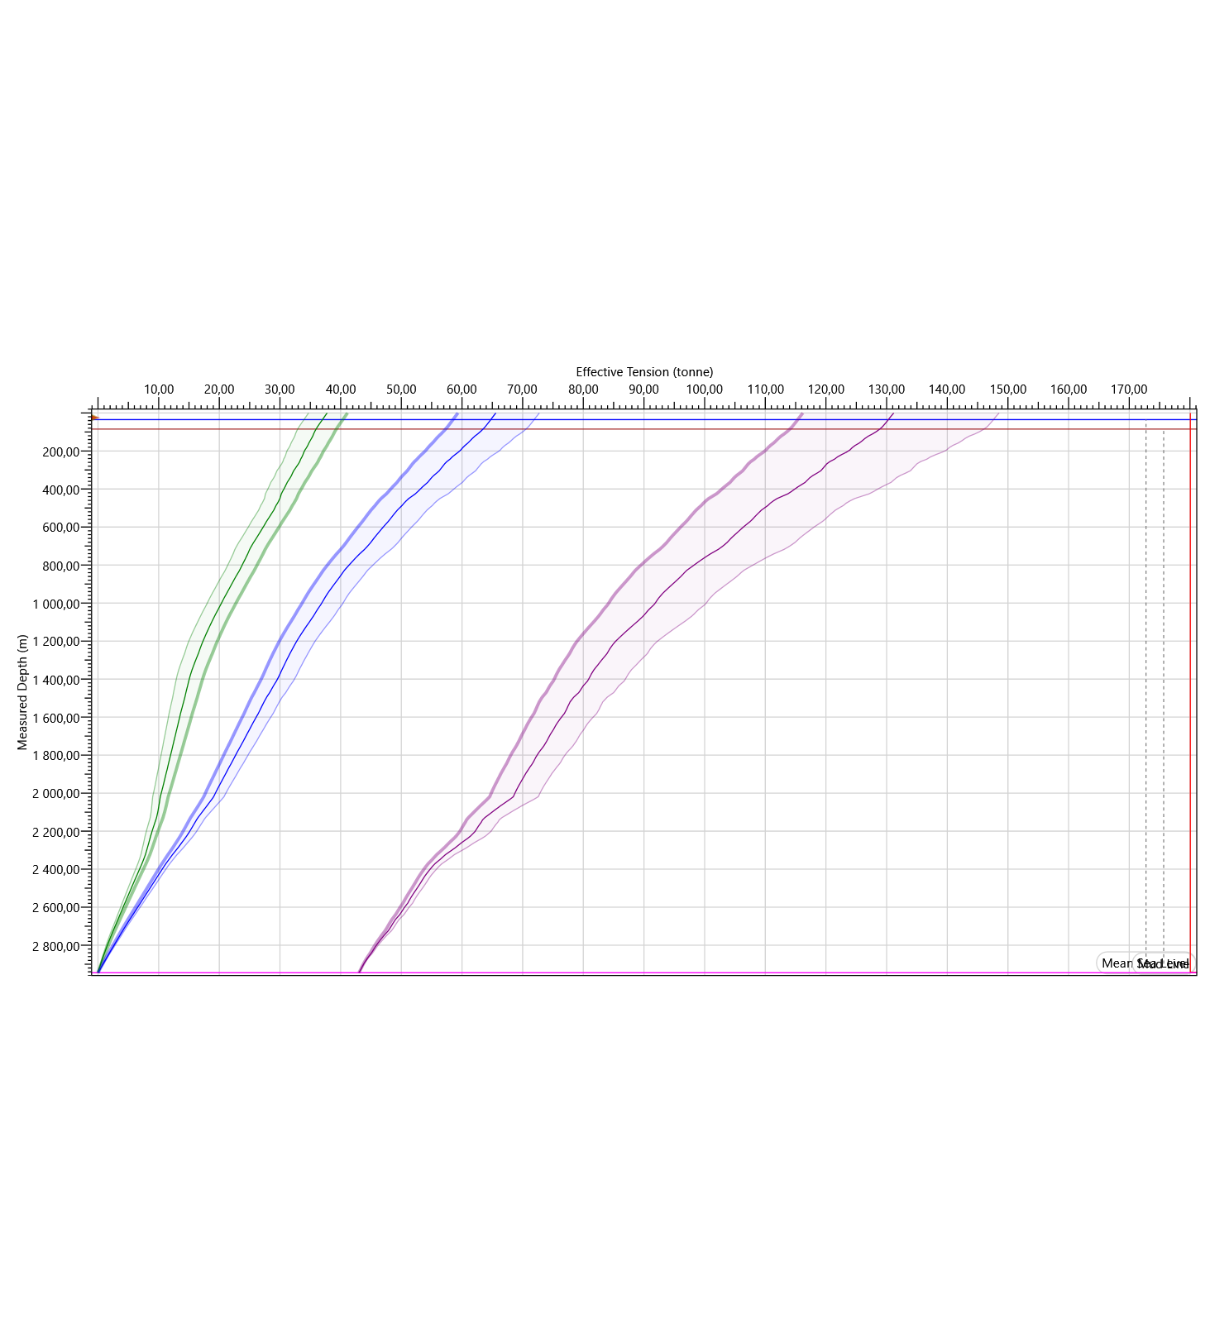
  - Hook Load
